Tabel Aturan Status Gizi Menurut PERMENKES Tahun 2020

(Laki-Laki)

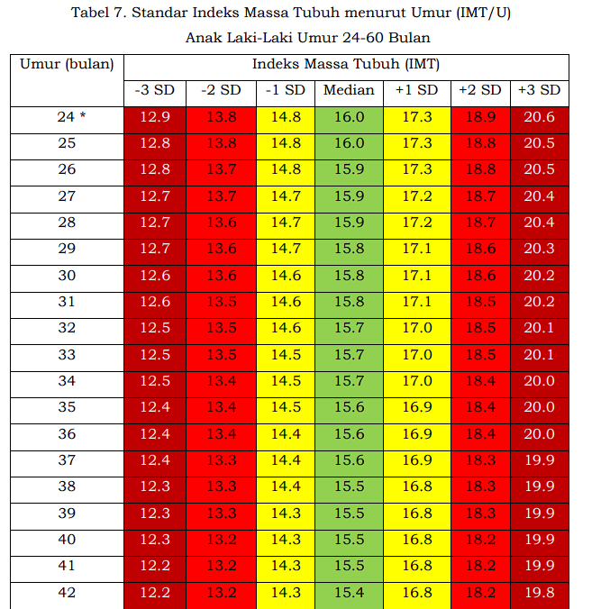

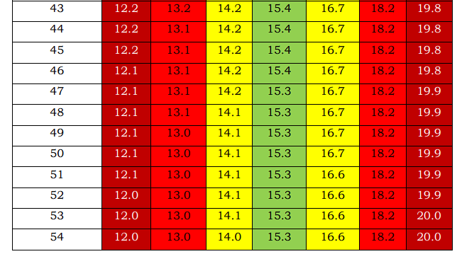

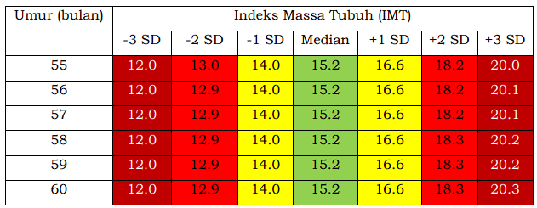

Tabel Aturan Status Gizi Menurut PERMENKES Tahun 2020

(Perempuan)

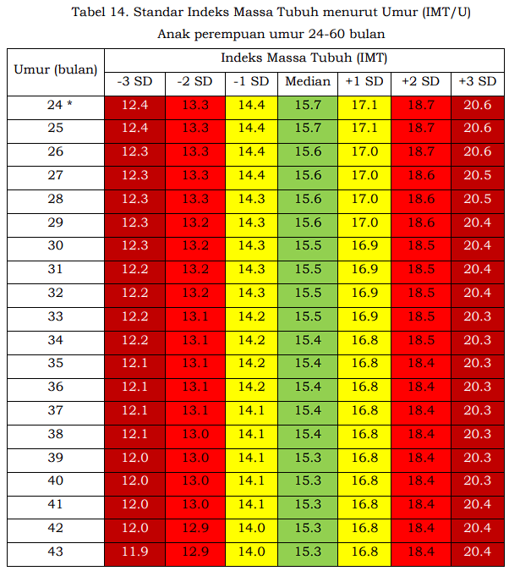

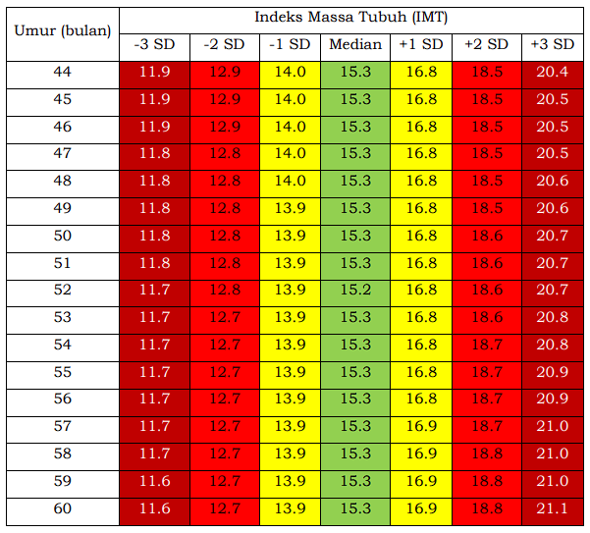

**STATUS KLASIFIKASI GIZI**

|  |  |  |  |  |  |  |
| --- | --- | --- | --- | --- | --- | --- |
| **- 3 SD** | **- 2 SD** | **- 1 SD** | **MEDIAN** | **+ 1 SD** | **+ 2 SD** | **+ 3 SD** |
| Gizi Buruk (Severely Wasted) | Gizi Kurang (Wasted) | Gizi Baik  (Normal) | Gizi Baik  (Normal) | Berisiko gizi lebih (Possible Risk of Overweight) | Gizi Lebih (Overweight) | Obesitas (Obese) |

